

Via Fax: (573)751-8115
Mr. Joshua Howell
Missouri Department of Revenue
General Counsel’s Office
Post Office Box 475
Jefferson City, Missouri 65105-0475

RE: Petitioner: Nicholas Archer
Docket No.: STLO0059
Case No.: AD23001865
DLN: C149032006
Hearing Date: July 12, 2023

Dear Mr. Howell:

Petitioner would like the Hearing Officer to review the documents on file with the Department of Revenue and make a decision based on these documents, having no additional evidence to submit. In particular, we call the Hearing Officer’s attention to the missing narrative in the Arrest Report received.

Please call me right away if there is an issue with this request or if you should have any questions. Thank you for your assistance and your courtesy.

Sincerely,

John C. Schleiffarth, P.C.
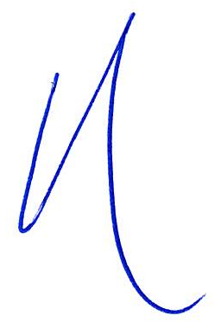
_/s/Andy Morris______________________
Andrew Morris #67504
75 West Lockwood Avenue, Suite 250
Webster Groves, Missouri 63119
Telephone: 314-561-9690
Facsimile: 314-596-0658
Email: john@jcsattorney.com
andy@jcsattorney.com
Attorney for Petitioner
JCS/taw
facsimile

